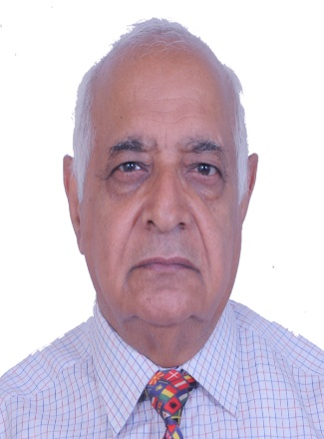

**MESSAGE**

Chairman Management Committee, Prof.P.L.Gautam

It gives me immense pleasure to welcome you all to the official website of our esteemed Shiv Shakti School — a vibrant centre of learning where tradition meets innovation, and values blend with vision.

**To our Teachers:**  
You are the torchbearers of wisdom and the architects of character. Your influence extends far beyond textbooks—you shape lives. As **Dr. Sarvepalli Radhakrishnan** said,

*“The true teachers are those who help us think for ourselves.”*  
And as **W. B. Yeats** wisely remarked,  
*“Education is not the filling of a pail, but the lighting of a fire.”*  
Thank you for igniting minds and nurturing excellence each day.

**To our Students:**  
You are the heartbeat of our institution—brimming with energy, potential, and promise. Embrace curiosity, dedication, and core values. In the words of **Dr. A.P.J. Abdul Kalam**,

*“Dream, dream, dream. Dreams transform into thoughts and thoughts result in action.”*  
Also, remember the timeless call of **Swami Vivekananda**:  
*“Arise, awake and stop not till the goal is reached.”*  
Education is not just a path to a career—it is the foundation of character and service to humanity.

**To Parents and Guardians:**  
Your unwavering support is our greatest strength. You are true partners in preparing our children for a dynamic and evolving world. As **Mahatma Gandhi** said,

*“Live as if you were to die tomorrow. Learn as if you were to live forever.”*  
Together, let us nurture in our children a lifelong love for learning and deep-rooted moral integrity.

**To the Management and Staff:**  
Your vision, dedication, and behind-the-scenes effort lay the foundation of every success we celebrate. Your steadfast commitment ensures our mission of holistic, value-based education is fulfilled with passion and purpose.

**To the Public at Large:**  
We believe that a school is not merely a place of learning, but a powerful institution for societal transformation. As **Dr. B.R. Ambedkar** powerfully stated,

*“Cultivation of mind should be the ultimate aim of human existence.”*  
Our school stands proudly committed to this ideal—promoting education that nurtures intellect, compassion, creativity, and responsible citizenship.

We draw inspiration from **Rabindranath Tagore**, who reminded us:

*“Don’t limit a child to your own learning, for he was born in another time.”*  
Our approach is **learner-centric**, **value-based**, and **future-ready**—geared to prepare students not just for examinations, but for life.

Let this website not be just a digital presence, but a reflection of our aspirations, achievements, and the spirit of learning that defines **Shiv Shakti School**.

*“Education is the best friend. An educated person is respected everywhere.”* — **Chanakya**  
*“Awake, arise and educate. Smash traditions – liberate!”* — **Savitribai Phule**

With warm regards and blessings,  
**Prof. P. L. Gautam**  
*Chairman, Management Committee*  
**Shiv Shakti School, Kasaroo, Bilaspur (H.P.)**

Top of Form

Bottom of Form